Sir Syed University of Engineering & Technology (SSUET)

Department of Software Engineering

Course Name: Artificial Intelligence (SE-314L)
Semester: 5th
Batch: 2023F
Section: “C”

PROJECT REPORT

Project Title: AI POWERED APDAPTIVE GAMING CONTROLLER


Submitted To:
Engr. Dur-e-Shawar Agha

Submitted By:
ARUBA HASSAN 2023F-SE-367
AMNA FARHAN 2023F-SE-110
TURAB HUSSAIN 2023F-SE-127

TABLE OF CONTENTS
S. No. | TOPICS | PAGE No.
1 | PROBLEM DOMAIN | 1
2 | PROPOSED TREATMENT | 2
3 | PLAN OF WORK | 3
4 | PROJECT SCHEDULING | 4
5 | SOFTWARE AND HARDWARE SPECIFICATIONS | 5
6 | BLOCK DIAGRAM | 6
7 | SYSTEM FLOW DIAGRAM | 7
8 | USER GUIDE | 8-10

TEAM PROFILE

- ARUBA HASSAN (2023F-SE-367)
(Research and planning, Game design)

- AMNA FARHAN (2023F-SE-110)
(Dataset collection, Model training)

- TURAB HUSSAIN (2023F-SE-127)
(Game development, Integration Voice commands)

1. PROBLEM DOMAIN
The project focuses on developing an AI-powered racing game controller that allows players to control a racing game using voice commands. Traditionally, racing games require players to interact with physical input devices such as keyboards, gamepads, or steering wheels. This conventional mode of control can be limiting, especially for players who prefer hands-free interaction or those with physical constraints that make traditional controllers difficult to use.
The need for this project arises from the growing demand for more intuitive and accessible gaming interfaces. By leveraging voice recognition and AI-based command interpretation, the system aims to create a more natural and adaptive gaming experience.

- THE OBJECTIVES OF PROJECT ARE:
- To develop a system capable of capturing and interpreting voice commands accurately in real-time.
- To convert recognized commands into actionable inputs for the racing game.
- To implement AI algorithms that adapt to player behavior, improving prediction and responsiveness.
- To provide a seamless interface that integrates with existing game engines and can operate in a real-time gaming environment.
- To maintain a reliable performance under various conditions, such as background noise or different player accents.

2. PROPOSED TREATMENT

To address the challenges identified in the problem domain, the project proposes the development of an AI-powered racing game controller that interprets voice commands and converts them into actionable game inputs. The solution integrates speech recognition, LSTM-based AI intent analysis, and game input mapping to provide a seamless and adaptive gameplay experience.
The approach to meet the project objectives includes the following key components:
- VOICE INPUT CAPTURE:
  - A microphone captures the player’s spoken commands in real-time.
- LSTM-BASED COMMAND INTERPRETATION:
  - An LSTM (Long Short-Term Memory) neural network processes the recognized text to determine the player’s intended action.
  - The system is specifically trained to recognize three voice commands:
    - "right" → turn the car right
    - "left" → turn the car left
    - "pause" → pause the game
  - By analyzing sequences of commands, the LSTM can anticipate the player’s next action, making the control more responsive and adaptive.
- GAME ACTION MAPPING:
  - The output of the LSTM is mapped to specific game actions:
    - "right" → press 'D' key (or right turn action in the game)
    - "left" → press 'A' key (or left turn action)
    - "pause" → trigger game pause functionality
- INTEGRATION WITH GAME ENGINE:
  - The controller is integrated with a racing game built using Pygame or another compatible engine.
  - Commands decoded by the LSTM are executed immediately, ensuring that the car moves or pauses according to the player’s voice input without noticeable lag.
- ADAPTABILITY AND FEEDBACK:
  - The LSTM model can learn the player’s voice patterns over time, improving recognition accuracy.
  - Optionally, a confidence score or recognition accuracy can be displayed to inform the player how reliably the system interprets commands.

3. PLAN OF WORK
3.1 PROJECT RESEARCH & PLANNING:
- Study AI car racing games and see how they work.
- Decide what features and functionalities our game will have that is levels, obstacles and voice command to control the game.
- Decide tools to design the game like pygame, pyTorch and librosa for voice command.

  - GAME DESIGN:

- Design the player’s car, other car, track and obstacles level wise.
- Plan how the car move and how the game levels look like.
- Decide designing structure that is welcome page, dashboard screen, level selection and then game over screen.
3.3 AI \ VOICE COMMAND:
- Create dataset of audios which consist of commands like “left”, “right”, “pause”.
- Train the AI model we use LSTM (Large Short Term Memory) model.
- Test the model that it works correctly in real time or not.

  - GAME DEVELOPMENT:

- Build the car racing game with pygame.
- Program car movement, obstacles appearance, manage collision and scoring system.
- Add sound on crash with obstacles.

  - INTEGRATON:

- Connect AI \ Voice command with car movement.
- Make sure the car move correctly according to voice input of user.
- Handles any delay so game runs smoothly.

  - TESTING:

- Play game and check car moves correctly.
- Check AI \ voice command accuracy.
- Fix any bugs or delay.

  - FINAL TOUCHES:

- Improves graphics and game performance.

PROJECT SCHEDULING

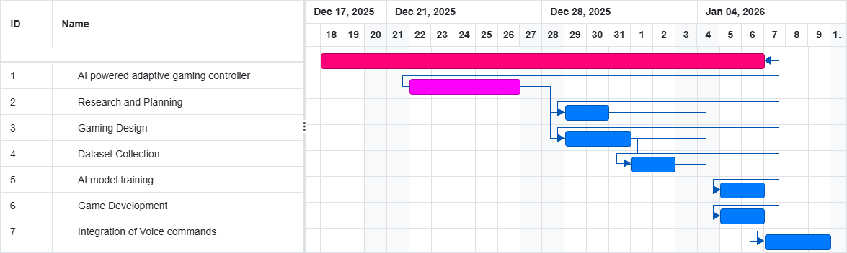
GANTT CHART:

5. SOFTWARE AND HARDWARE SPECIFICATIONS
This project describes the following requirements:
- HARDWARE REQUIREMENTS:
- Processor: Intel(R) Core(TM) i5-6300U CPU @ 2.40GHz – exceeds the recommended 2 GHz
- RAM: 8 GB – exceeds the recommended 4 GB
- Hard Drive: 238 GB SSD – exceeds the recommended 64 GB
- Graphics: Intel(R) HD Graphics 520 – sufficient for lightweight game rendering
- Network: Supports Ethernet and Wi-Fi
- Sound Card & Speakers: Integrated audio available
- Microphone: External/Integrated microphone used for voice input
- SOFTWARE REQUIREMENTS:
- VS Code

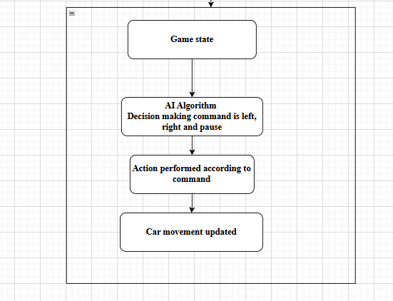
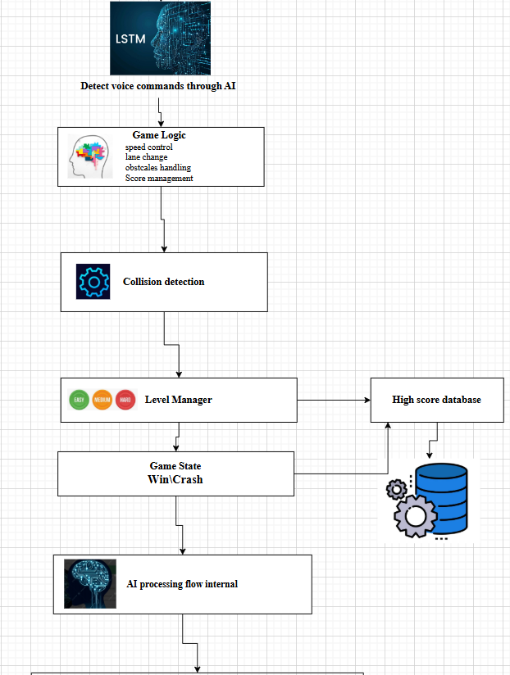
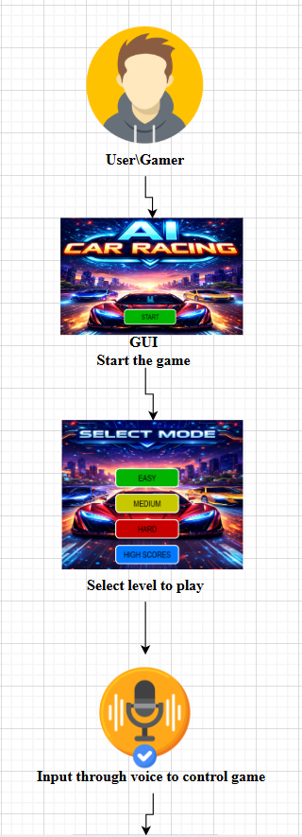
6. BLOCK DIAGRAM

SYSTEM FLOW DIAGRAM
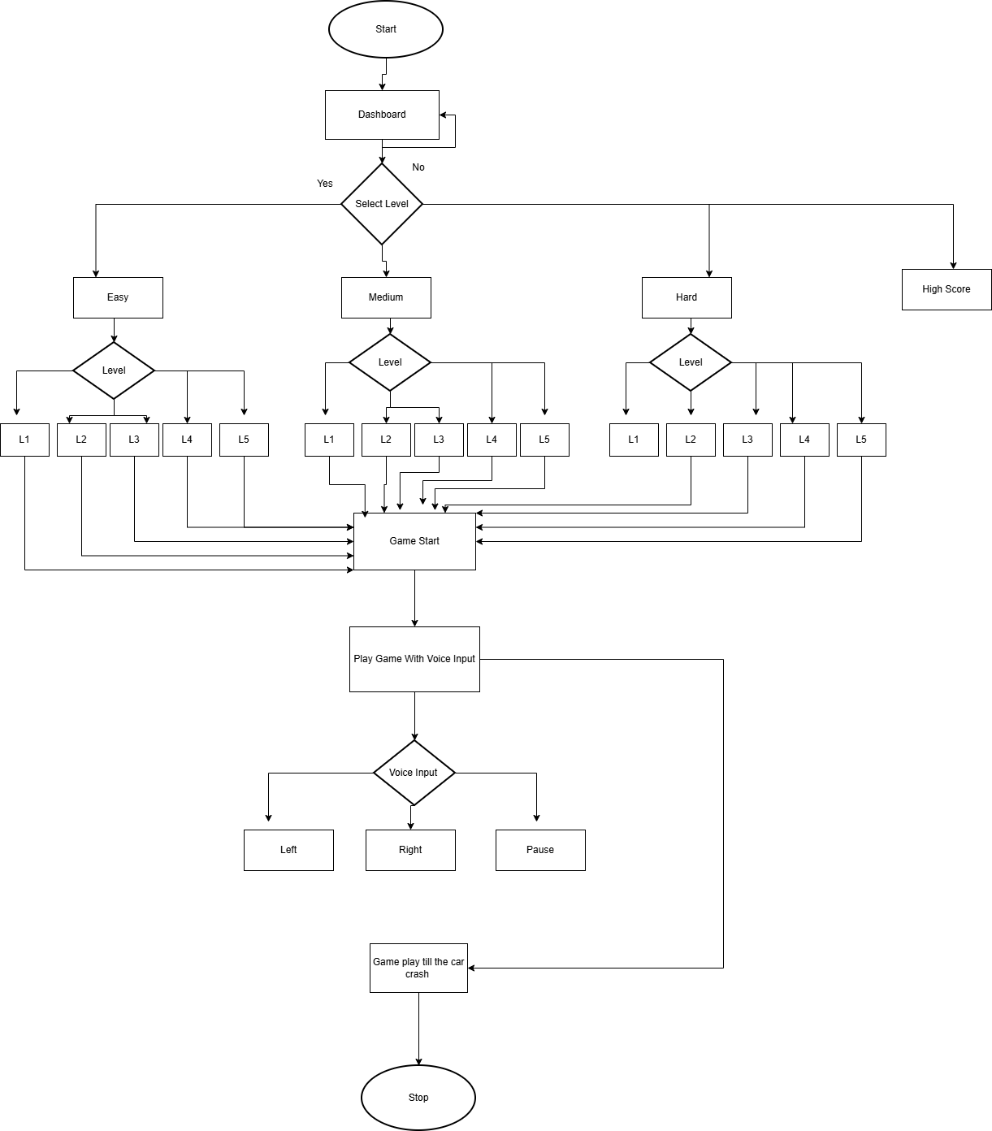

8. USER GUIDE
Explain through screenshots, how the end users will interact with your developed project. Describe the whole process step by step.

1. HOW TO START GAME:
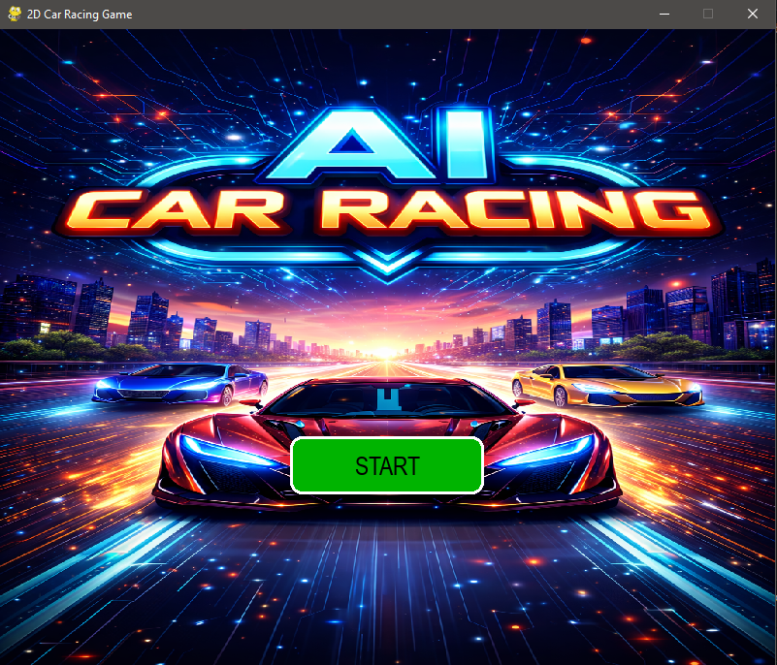
The first thing your to start our Car Racing Game is to click “START” button.

2. HOW TO GO TO THE DASHBOARD:
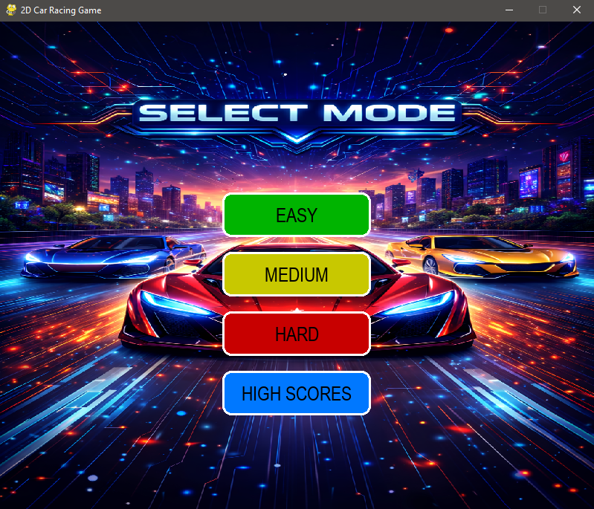
After clicking the START button the dashboard appears which shows four buttons “EASY”, “MEDIUM”, “HARD” for level selection and “HIGH SCORE” button for check high score.

3.HOW TO SELECT SUB-LEVELS:
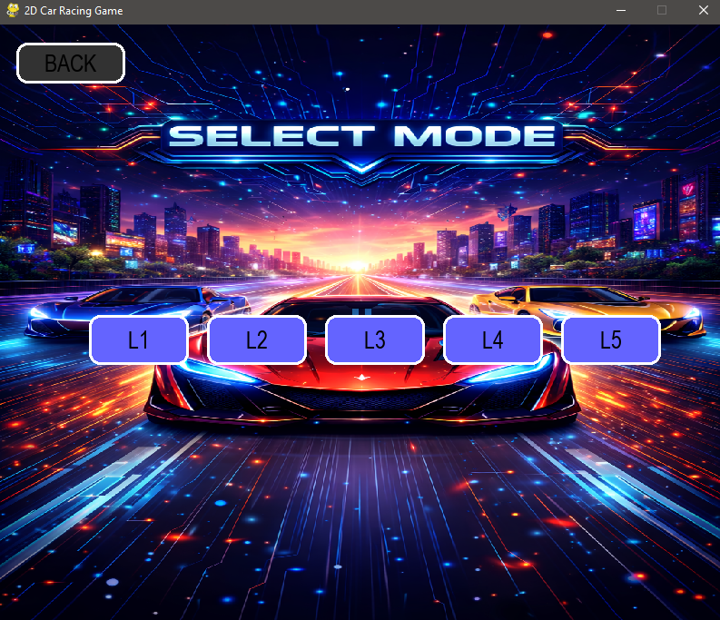
After selecting the level you want to play the sub levels appear. Choose want level you want to play.

4.WHEN CLICK ON HIGH SCORE BUTTON
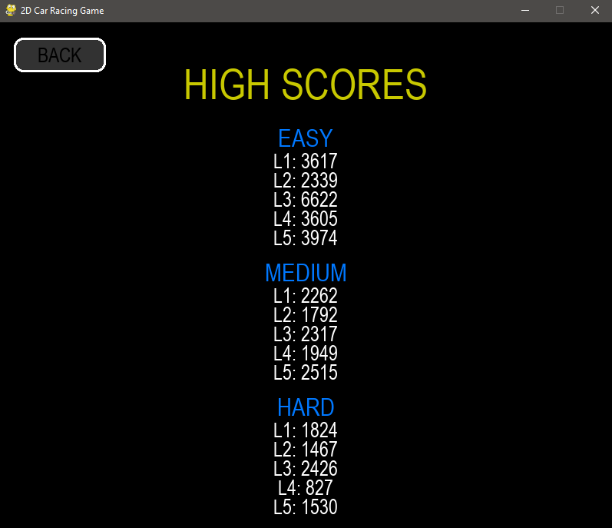
If the user select “HIGH SCORE” button the all levels scores appears.

5.GAME START TO PLAY WITH AI \ VOICE COMMANDS:
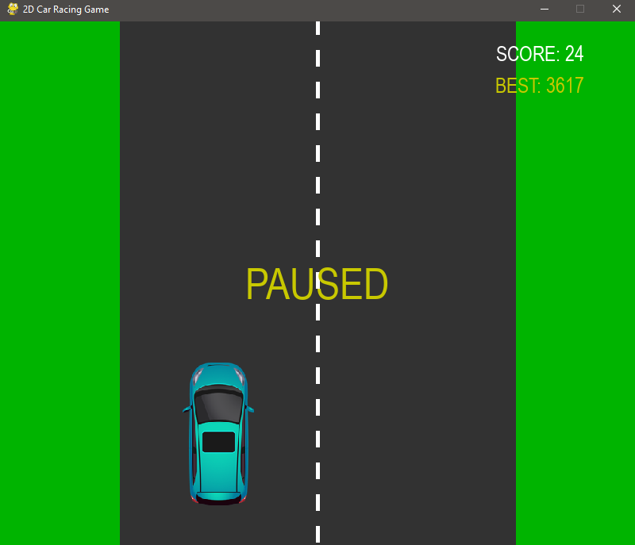
After selecting the level which you want to play the game begins.

6.WHEN CAR CRASHES WITH OBSTACLE:
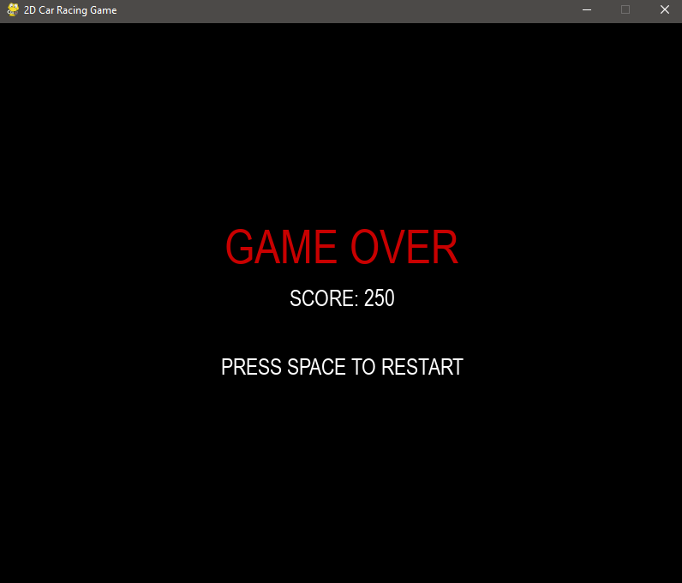
After the car crash the “GAME OVER” window appears which shows your score and option to restart game.

REFERENCES

- Pygame documentation:
https://www.pygame.org/docs/
- Pytorch documentation:
https://pytorch.org/docs/stable/index.html
- Librosa documentation:
https://librosa.org/doc/latest/index.html
- Gantt chart maker:
https://ganttchartmaker.com/?utm_source=chatgpt.com
- Sound device python module:
https://python-sounddevice.readthedocs.io/

